User模块 2

Browse模块 2

Strategy模块 4

Credit模块 5

Order模块 6

Hotel模块 8

Member模块 9

Comment模块 10

## User模块

耦合

|  |  |  |
| --- | --- | --- |
| 类名 | CBO | DAC |
| UserController | 8 | 2 |
| 调用其他类4，被其他类调用4 | MemberController  User |

|  |  |  |
| --- | --- | --- |
| 类名 | CBO | DAC |
| User | 7 | 1 |
| 调用其他类4，被其他类调用3 | UserPO |

内聚

UserController

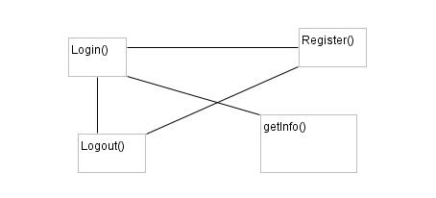

User

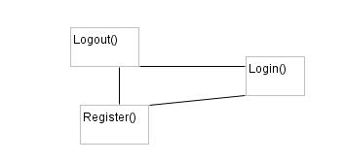

## Browse模块

耦合

|  |  |  |
| --- | --- | --- |
| 类名 | CBO | DAC |
| BrowseController | 20 | 1 |
| 调用其他类10，被其他类调用10 | Browse |

|  |  |  |
| --- | --- | --- |
| 类名 | CBO | DAC |
| Browse | 26 | 7 |
| 调用其他类16，被其他类调用10 | BrowsePO  MemberController  CreditController  StrategyController  HotelController  CommentController  OrderController |

内聚

BrowseController

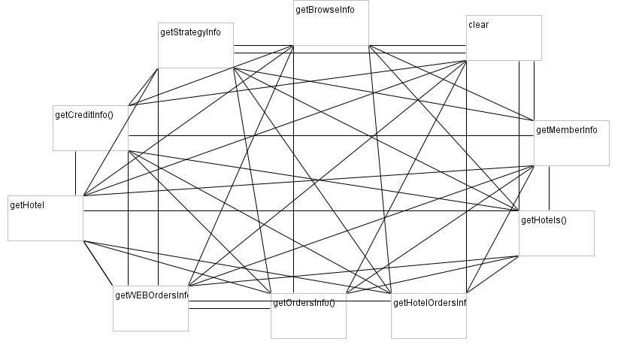

Browse

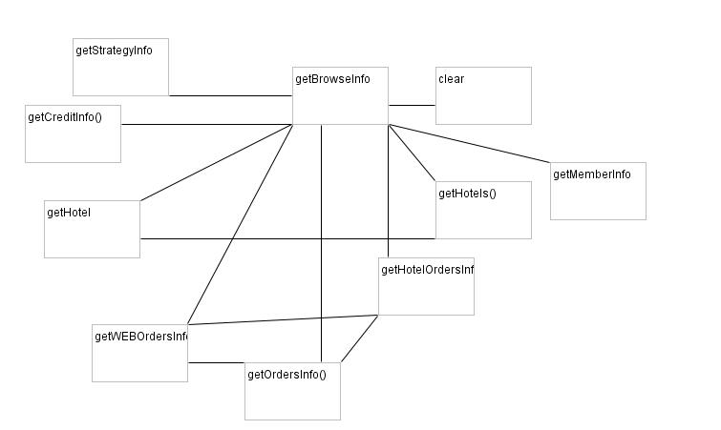

## Strategy模块

耦合

|  |  |  |
| --- | --- | --- |
| 类名 | CBO | DAC |
| StrategyController | 10 | 2 |
| 调用其他类7，被其他类调用3 | Stratgey  HotelController |

|  |  |  |
| --- | --- | --- |
| 类名 | CBO | DAC |
| Strategy | 16 | 2 |
| 调用其他类9，被其他类调用7 | StrategyPO  HotelController |

内聚

StrategyController

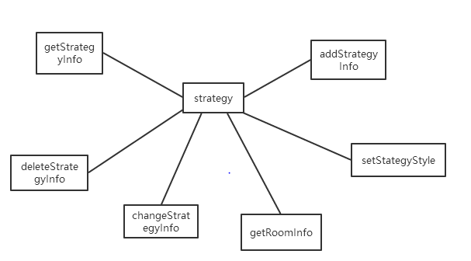

Strategy

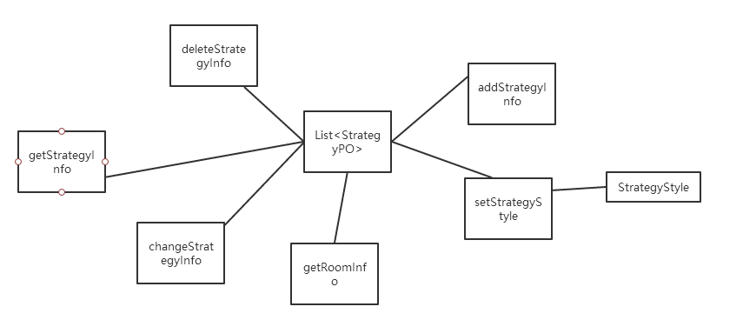

## Credit模块

|  |  |  |
| --- | --- | --- |
| 类名 | CBO | DAC |
| CreditController | 8 | 2 |
| 调用其他类6，被其他类调用2 | Credit  UserController |

|  |  |  |
| --- | --- | --- |
| 类名 | CBO | DAC |
| Credit | 5 | 1 |
| 调用其他类2，被其他类调用3 | CreditPO |

CreditController

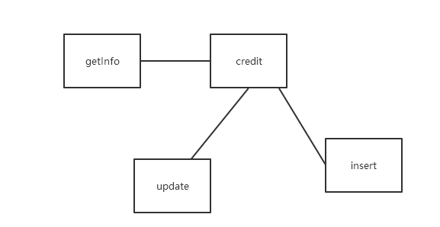

Credit

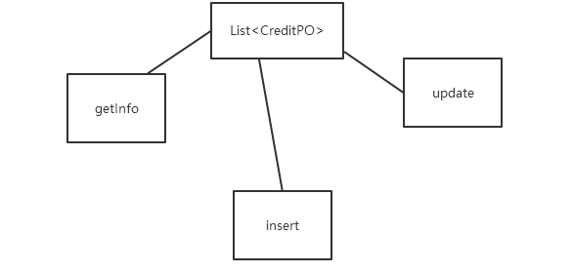

## Order模块

耦合

|  |  |  |
| --- | --- | --- |
| 类名 | CBO | DAC |
| OrderController | 8 | 2 |
| 调用其他类4，被其他类调用4 | MemberController  User |

|  |  |  |
| --- | --- | --- |
| 类名 | CBO | DAC |
| Order | 7 | 1 |
| 调用其他类4，被其他类调用3 | UserPO |

内聚

OrderController

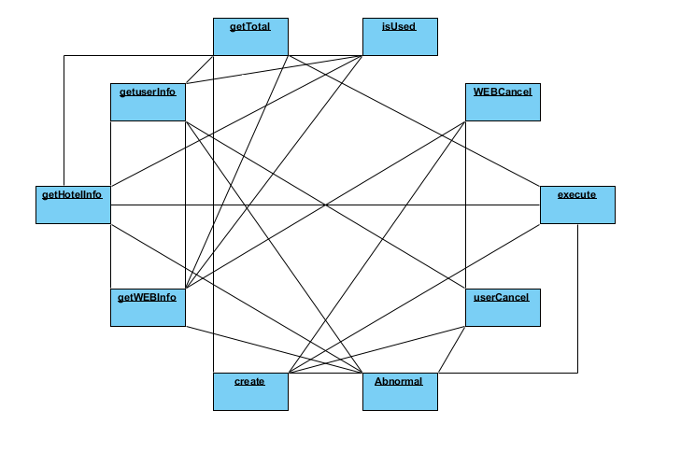

Order

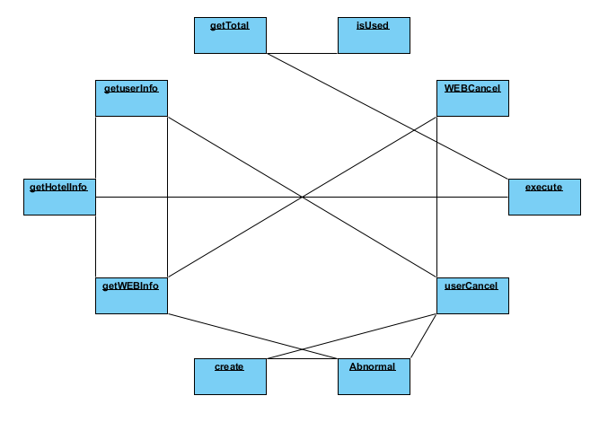

## Hotel模块

耦合

|  |  |  |
| --- | --- | --- |
| 类名 | CBO | DAC |
| HotelController | 8 | 2 |
| 调用其他类4，被其他类调用4 | MemberController  User |

|  |  |  |
| --- | --- | --- |
| 类名 | CBO | DAC |
| Hotel | 7 | 1 |
| 调用其他类4，被其他类调用3 | UserPO |

内聚

HotelController

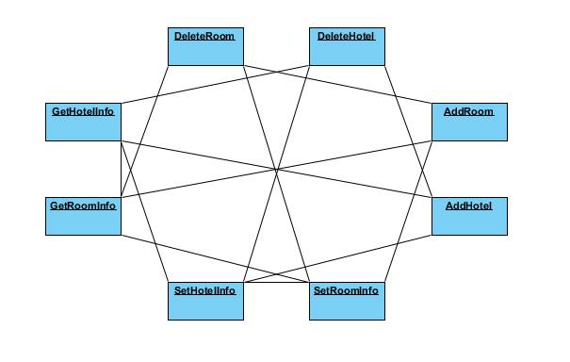

Hotel

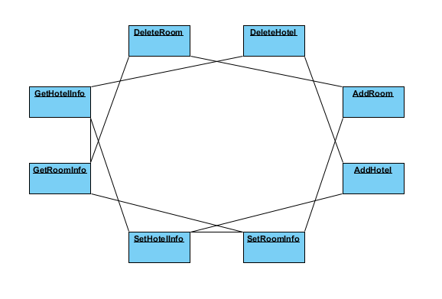

## Member模块

耦合

|  |  |  |
| --- | --- | --- |
| 类名 | CBO | DAC |
| MemberController | 10 | 2 |
| 调用其他类6，被其他类调用4 | Member |

|  |  |  |
| --- | --- | --- |
| 类名 | CBO | DAC |
| Member | 10 | 1 |
| 调用其他类4，被其他类调用6 | MemberPO |

MemberController

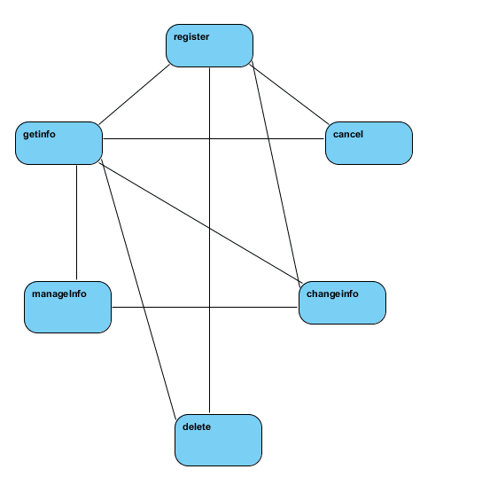

Member

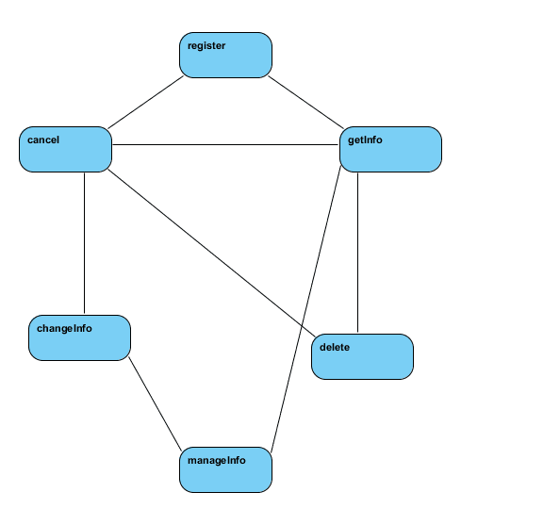

## Comment模块

耦合

|  |  |  |
| --- | --- | --- |
| 类名 | CBO | DAC |
| CommentController | 4 | 1 |
| 调用其他类2，被其他类调用2 | Comment |

|  |  |  |
| --- | --- | --- |
| 类名 | CBO | DAC |
| Comment | 4 | 1 |
| 调用其他类2，被其他类调用2 | CommentPO |

CommentController

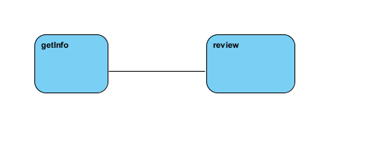

Comment

